# Case Study: Business Analyst – I

Amazon E-commerce Dashboard

Overview Dashboard:

In my Amazon e-commerce dashboard, I've created seven distinct modules to comprehensively analyse various aspects of the data. The first module, the **Home** **Page**, is the initial landing area, incorporating design elements. The **Summary** module provides an overview of key metrics and insights. The **Product** module focuses on detailed product-related data, while the **Rating** module analyzes seller ratings to assess customer satisfaction. The **Seller** module delves into seller-specific information and performance metrics. The **Seller Location** module visualizes geographic data related to seller distribution. Finally, the **Focused/Improvements** module highlights areas for potential enhancement and key takeaways for further action.

Dashboard Images Using (PowerBI Tool):

Home_Page:

Summary_Page:

Product Count Distribution:

Ratings_Pages:  
  
Seller Information_Page:  
  
Seller Location_Page:  
  
Improvements Pages:  
  
Insights Observed:

1. **Insight**: Sellers with many products showcase a diverse portfolio and strong market presence.  
     
   A screenshot of a report

   Description automatically generated

**Observation**: A card visualization highlights sellers with a large product count, indicating their broad portfolio and significant market influence.

1. **Insight**: High product counts in specific locations indicate strong market presence and product diversity, highlighting strategic acquisition opportunities in key regions.

**Observation**: The map shows locations with high product counts, revealing a strong market presence and indicating potential strategic acquisition opportunities in these key regions.

1. **Insight**: This chart identifies top sellers in each country based on product count or sales volume metrics, aiding in market strategy and expansion.

**Observation**: The bar chart reveals top sellers in each country based on product count or sales volume, aiding in market strategy and expansion planning.

1. **Insight**: The column chart shows the top-selling brands per country, highlighting market leaders and popular brands for strategic marketing and distribution decisions.

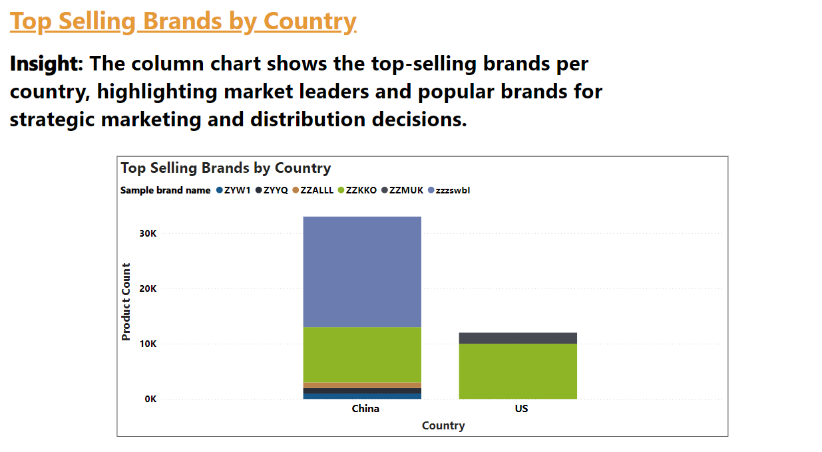

**Observation**: The column chart reveals the top-selling brands in each country, pinpointing market leaders and key brands to inform marketing and distribution strategies.

1. **Insight**: The table identifies sellers in each country with the lowest positive rating percentages, highlighting areas for targeted improvements and strategic actions to boost customer satisfaction.

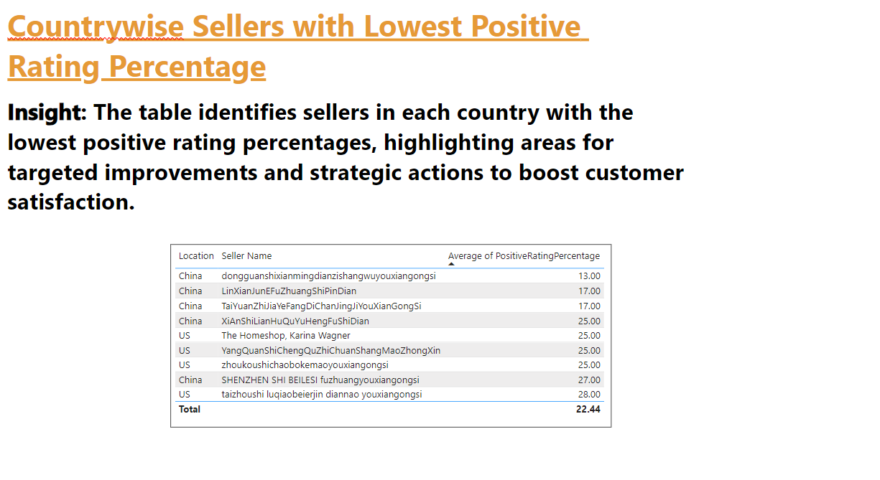

**Observation**: The table shows sellers with the lowest positive rating percentages by country, pinpointing where customer satisfaction is lacking and where improvements are needed.

--------------------------- Thank You--------------------------------